**TV MANUFACTURING COMPANY WEBSITE**

**TEAM MEMBERS:**

|  |  |
| --- | --- |
| 20ITR038 | JANARTHANAN T |
| 20ITR052 | KIRUTHIKA G |

**OUTPUT:**

**SIGN UP PAGE:**

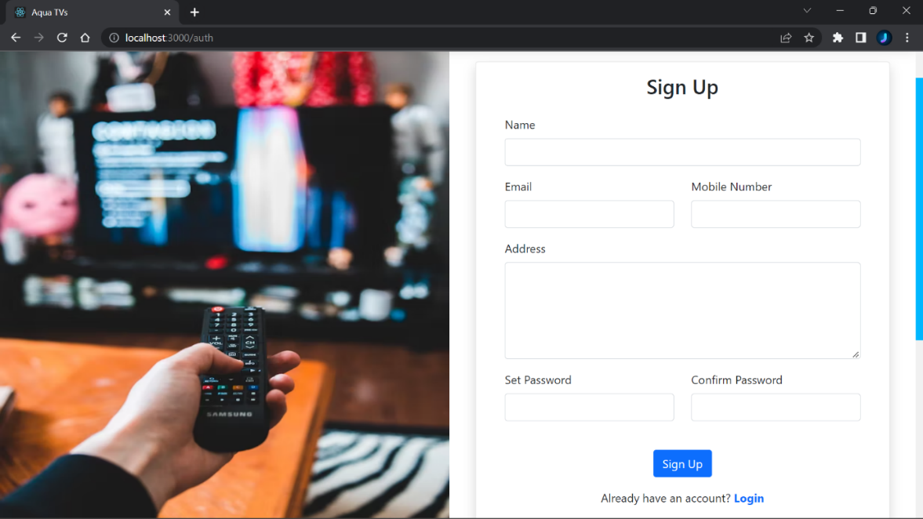

**LOGIN PAGE:**

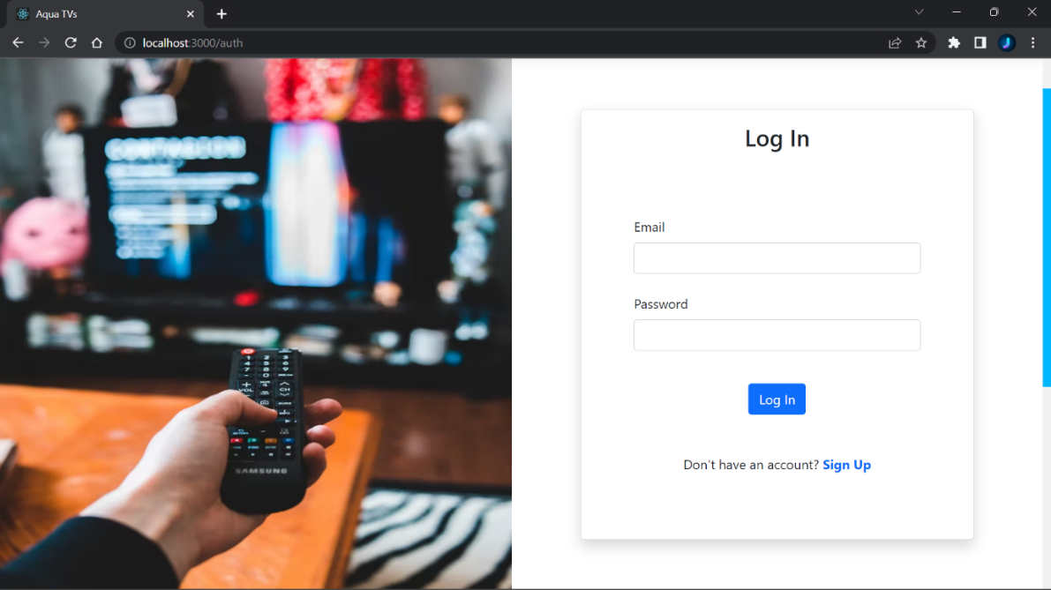

**HOME PAGE:**

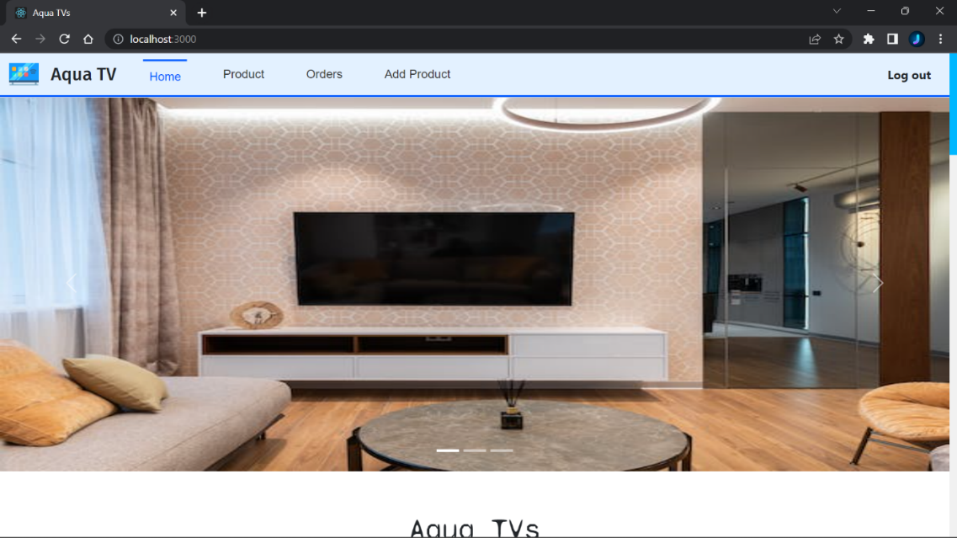

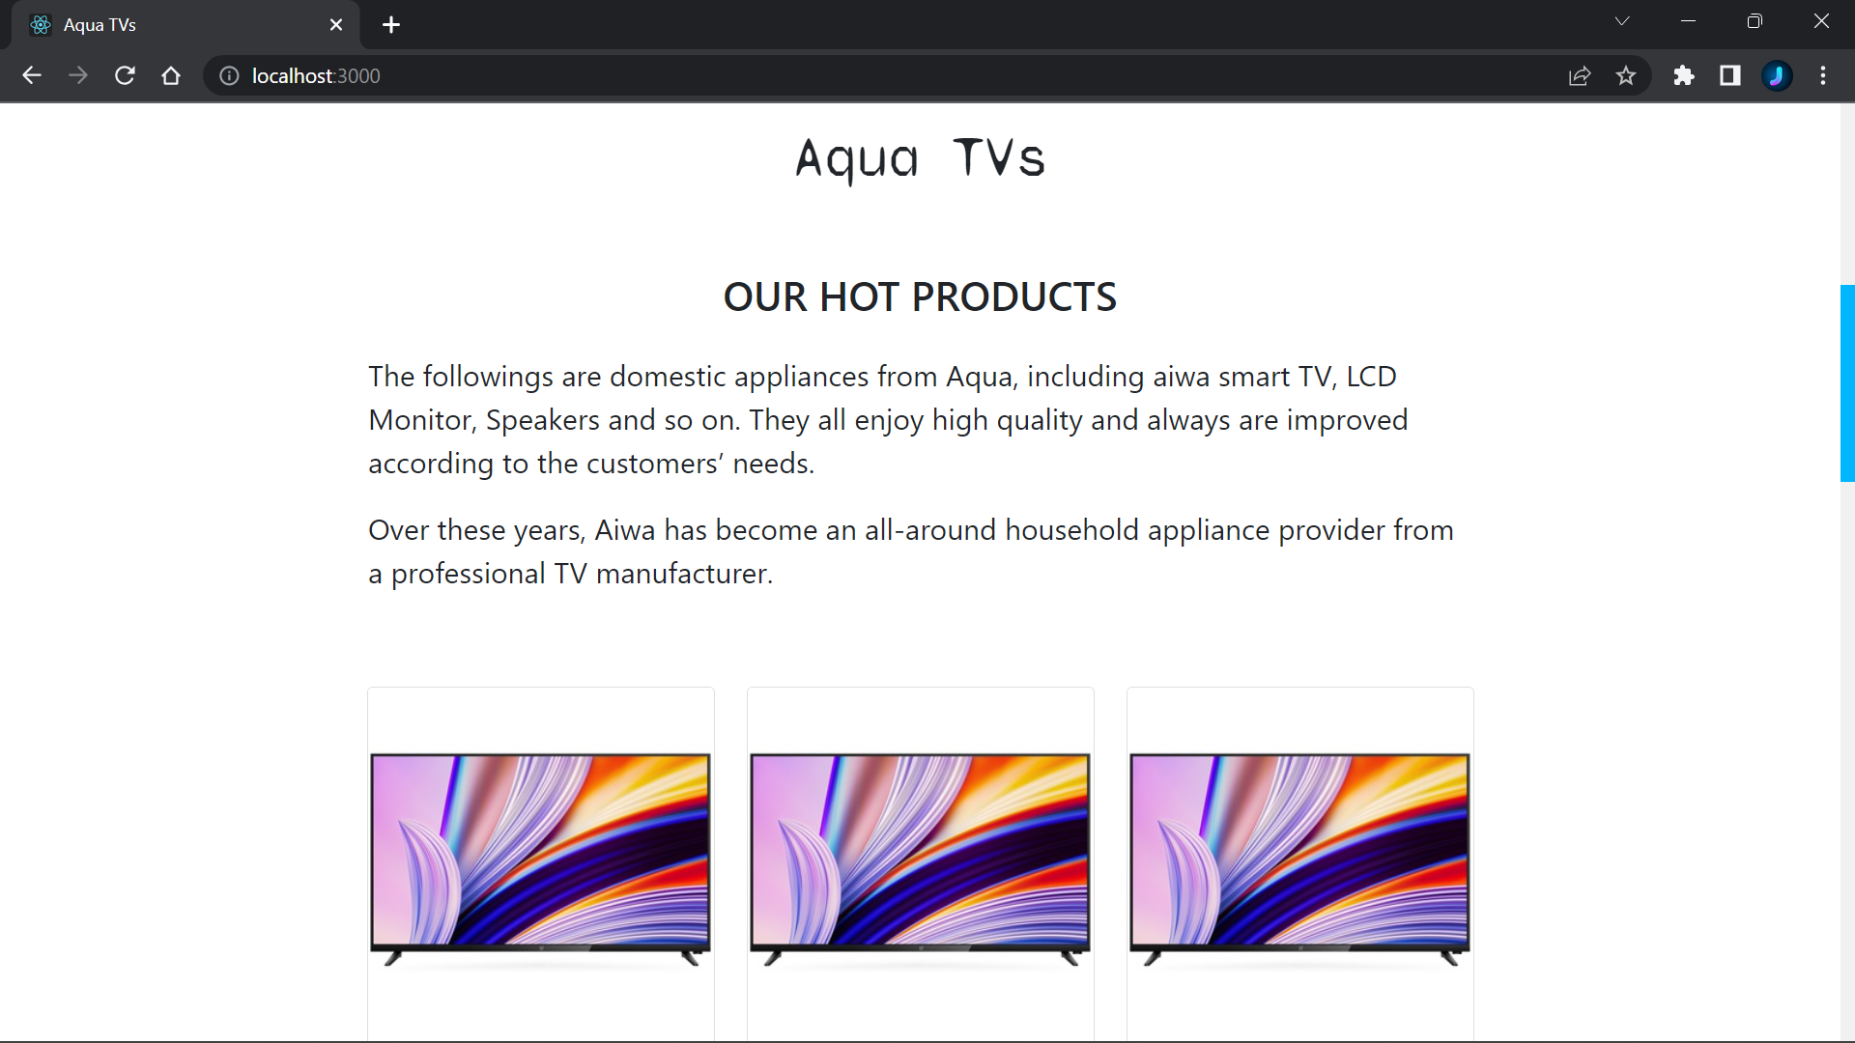

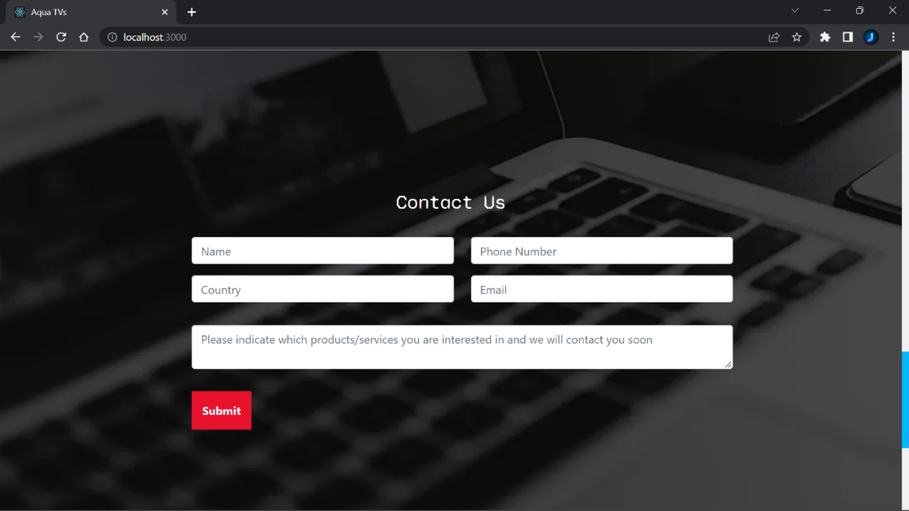

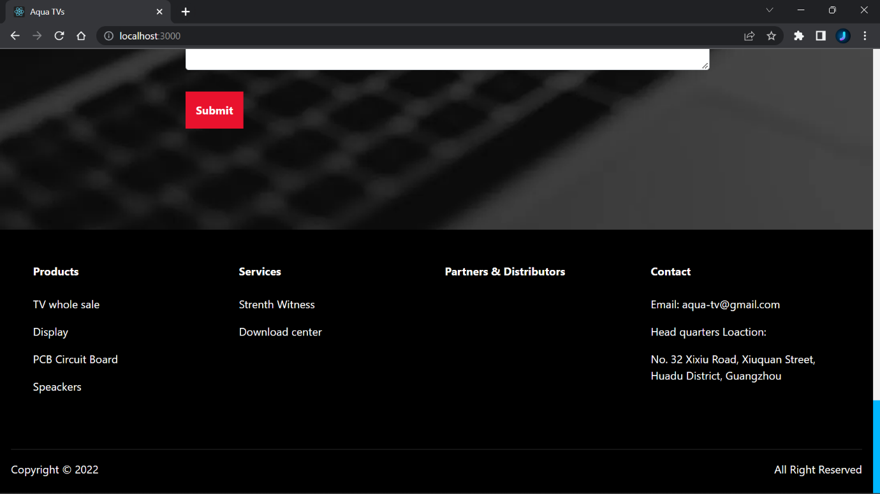

**PORDUCT PAGE:**

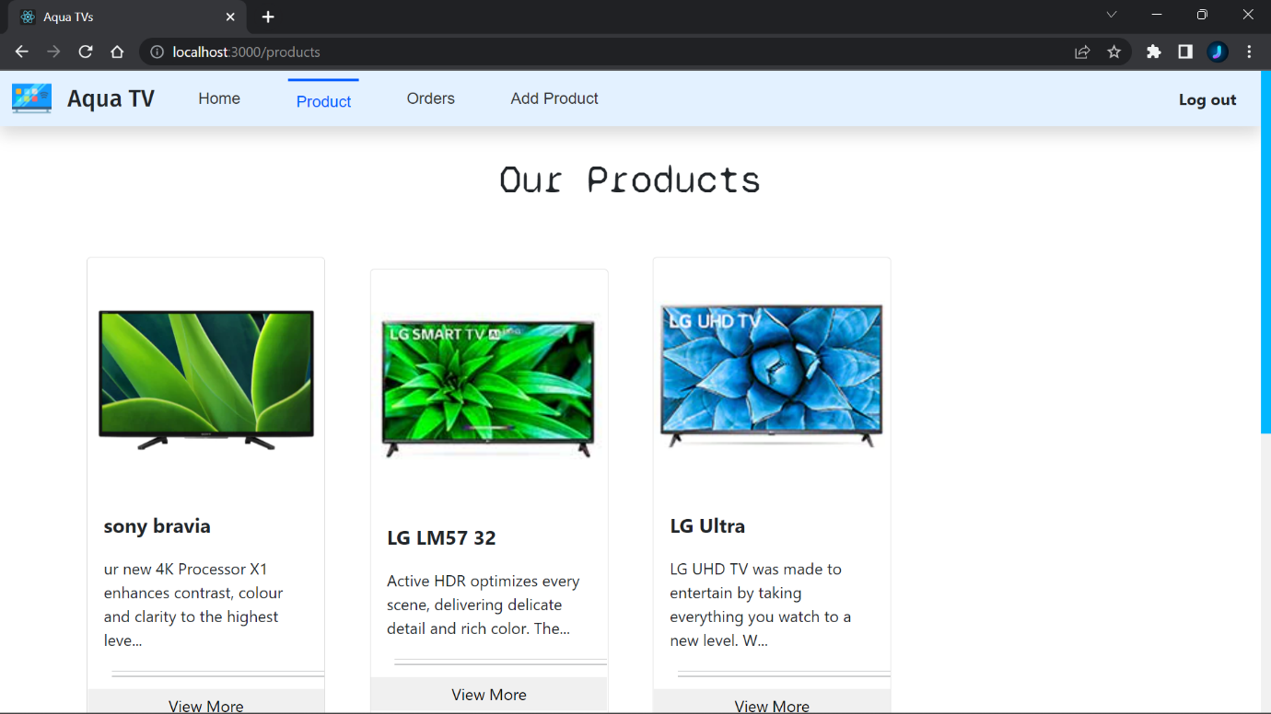

**ADMIN ADD PRODUCT PAGE:**

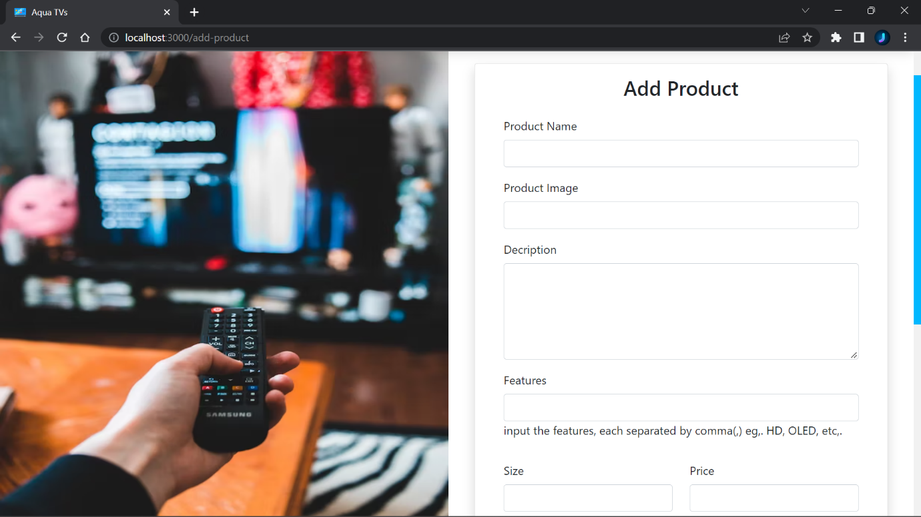

**ADMIN ORDERS PAGE:**

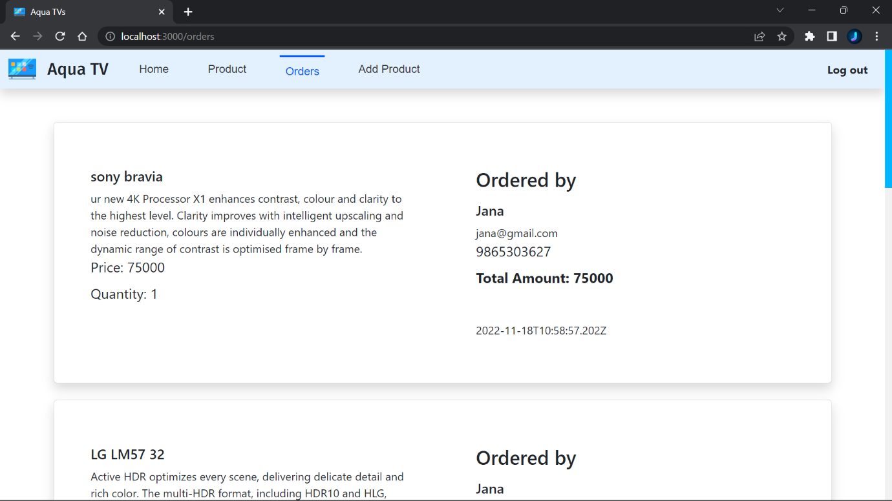

**ABOUT US PAGE:**

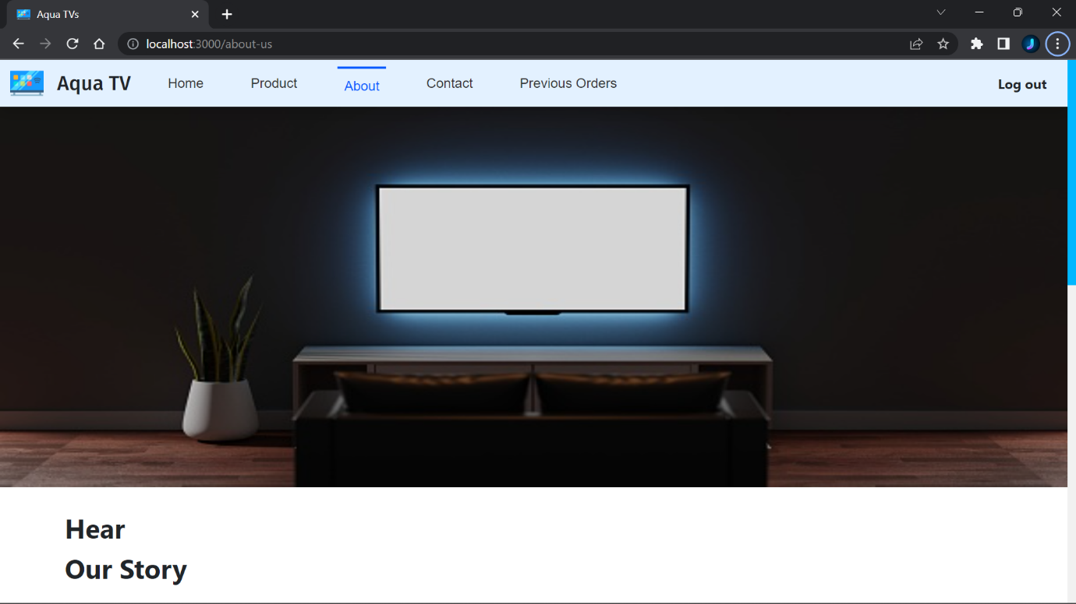

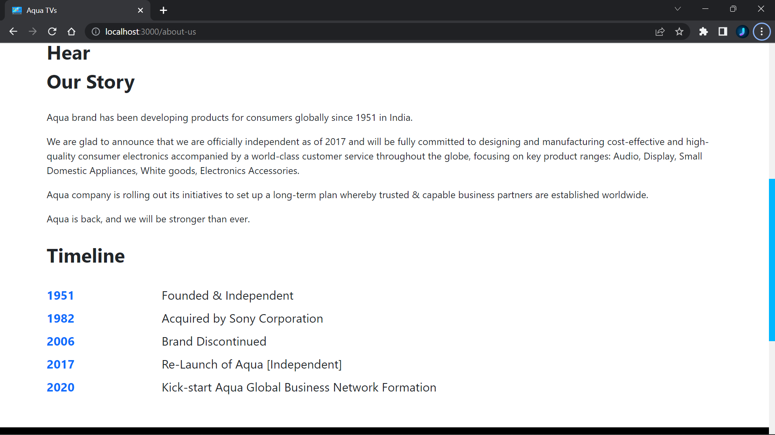

**CONTACT US PAGE:**

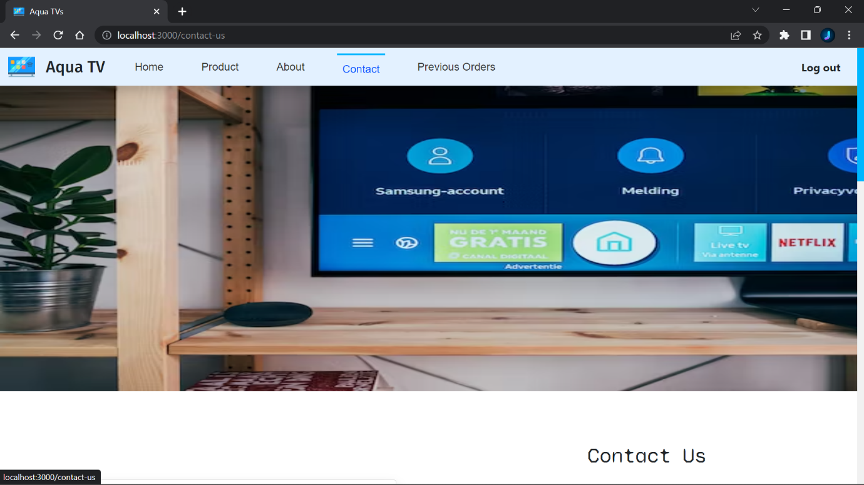

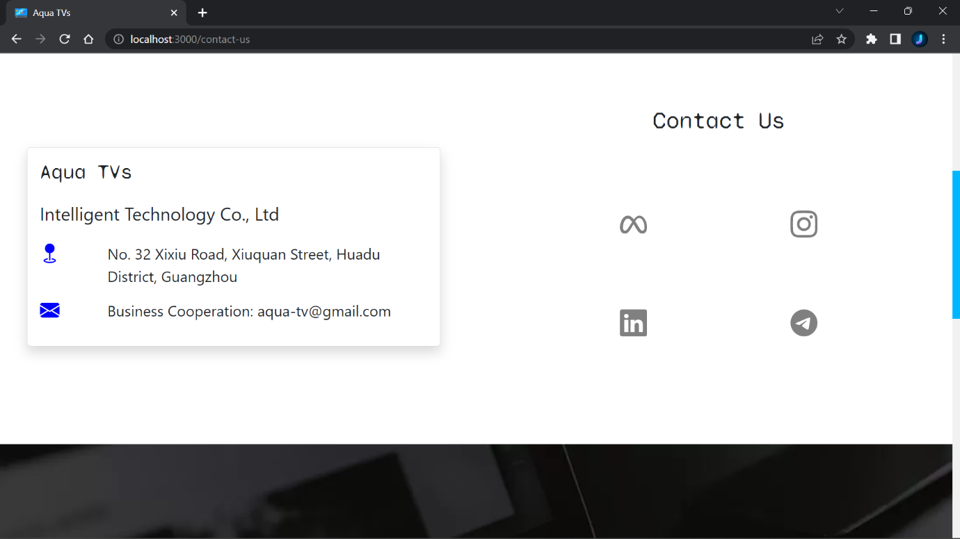

**PRODUCT SHOW PAGE:**

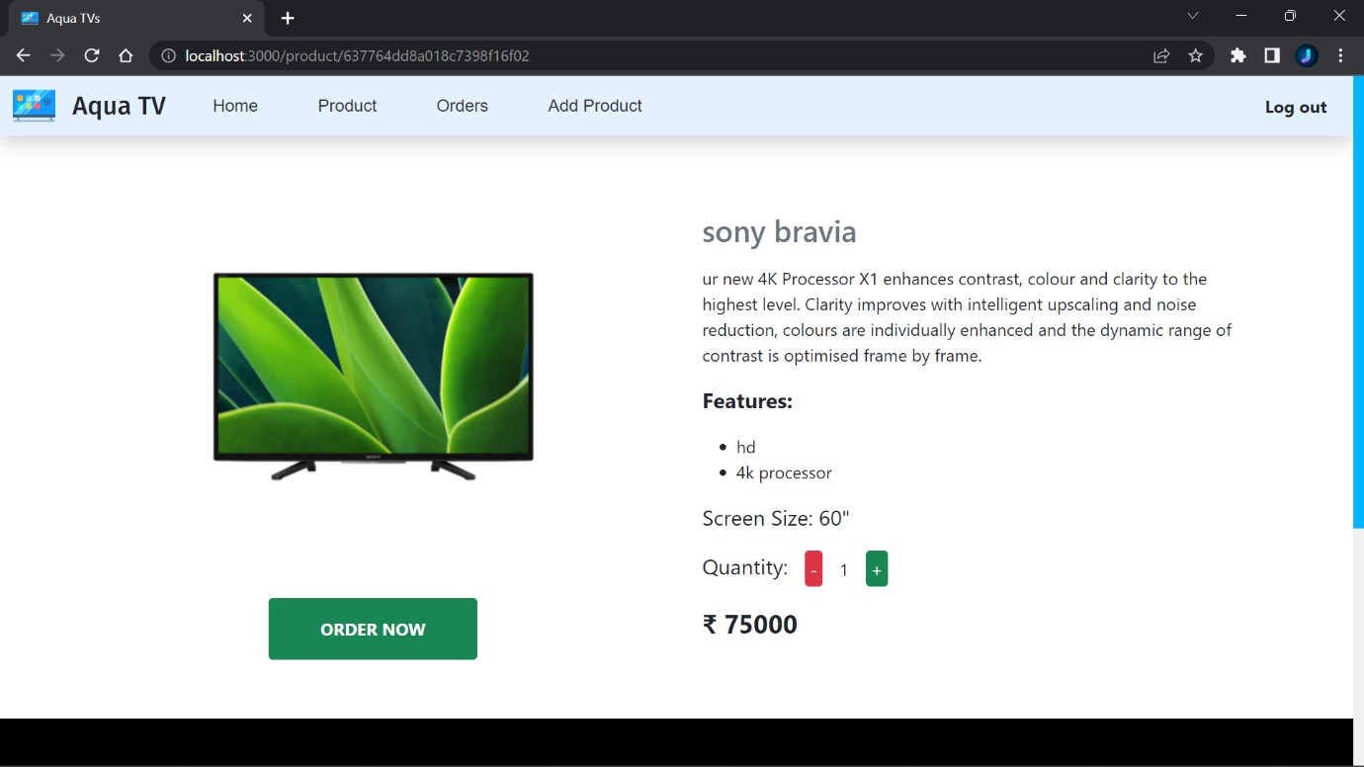

**PREVIOUS ORDERS PAGE:**

